Idea Documentation

- Use case Overview

The project is titled INWADIS (Intelligent water distribution system) and the goal is to make existing water distribution system in the urbans as SMART by adding Programmable Object Interfaces, Centralised data analytics, Dashboards and Knowledge engineering. After analysing water distribution system in various localities in the cities like Kolkata we observed the growing problem of water shortage due to non uniform water distribution and leaking supply systems. INWADIS ensures controlled and uniform water distribution system for every household to meet their own needs regularly.

This system will ensure its operational maintenance responding rapidly and transparently keeping authorities and consumers in the loop by ensuring a continuous supply of water while constantly optimizing our networks performance this system is a long term guarantee of operational efficiency for cities and the consumers.

2. Use Case Description

Water managers are facing growing challenges, including aging infrastructure, rising energy costs and growing populations. Intelligent water distribution system helps solve these challenges through self-optimizing equipment and analytics that support proactive decisions.

Intelligent Water Distribution System is a way to collect, share and analyze data from water equipments,sensors embedded with them and water networks. It is used by water managers to find leaks, lower energy use, predict equipment failure, and ensure regulatory compliance.
2.1 Current System
The current water system available to us has no such facility of providing enhanced and adequate water supply.One of the most important thing is that there is no check on the wastage of water.Let us consider the issues related to different sections.

- Consumers(or Customers)
- With shrinking water resources, low rainfall etc it is hard to feed and provide water thus causing frequent water crisis in a city or urban locality.
- Domestic users are unaware of the ongoing leakage in their water system.
- Water consumption has been the major reason for Energy crisis since pumping water requires huge amount of electricity.
- Technicians
- It takes time to figure out what and where exactly the problem is or to locate it and thus it creates delay in the repair.
- Issues related to problem solving .Since technicians are not the same thus they are unable to find out the solution.
- Also due to insufficient information it often creates problem in predicting the exact tool/repair equipments for the job.
- Technicians also find it hard to deal the new issues which does not falls under their domain of experience or knowledge.There is no method for providing assistance to them.
- Maintenance management
- Find it hard to assign technicians according to the required or obtained schedule.
- Obviously doesn’t have access to real time problems and also information related to the requirement of water in different arenas.
- Lack of facts and figures through which an equitable distribution of water system could have been planned.
- Also there can be a situation of scarcity in the stock for the required parts and tools.

2.2 Proposed Solution

Our aim is to make the current system smart. The proposal is designed considering all the issues discussed and fixing them. Now for each of the following stakeholders we have figured out the solutions.

- Customers
- Sensors provide real time monitoring of hydraulic data with automated control and alarming in case of events such as water leakages etc.
- Also Smart system displays detail about the present water quality by measuring the amount of chlorine and other metals.
- Smart water system provides reduced water non-renewable water losses and reduced water consumption in field of agriculture.
- Technicians
- Analysis of data will help in taking meaningful actions according to the problem.
- Location information of the water unit facing problem with the help of GPS.
- Ease in selection of tools for the job.
- Also the smart system comes with a AR procedure for step by step solving the issue.
- Comes with an app to check the status of particular water unit helping the technicians when they are on move.
- Maintenance Management
- Guides strategy and investment through data analytics.
- It also helps in dealing the unattended issues thus removing the probability of big upcoming problems.
- Helps in maintaining the stock of tools and parts or equipments related to the repairing of water system.
- Also provides geotagged information related to the request been placed or old issues of concerns.

The present water crisis has many components of an environmental, economic and social origin: overuses of water, pollution, changes in availability, and water mismanagement are some of the current problems.

3. Architecture
As discussed, the solution to our problem area is considered at three levels, ie on the Consumer level, Technician and the maintenance management level. This way we create asynergy between the stakeholders of the system.
The architecture of the proposed solution is as per the below figure.
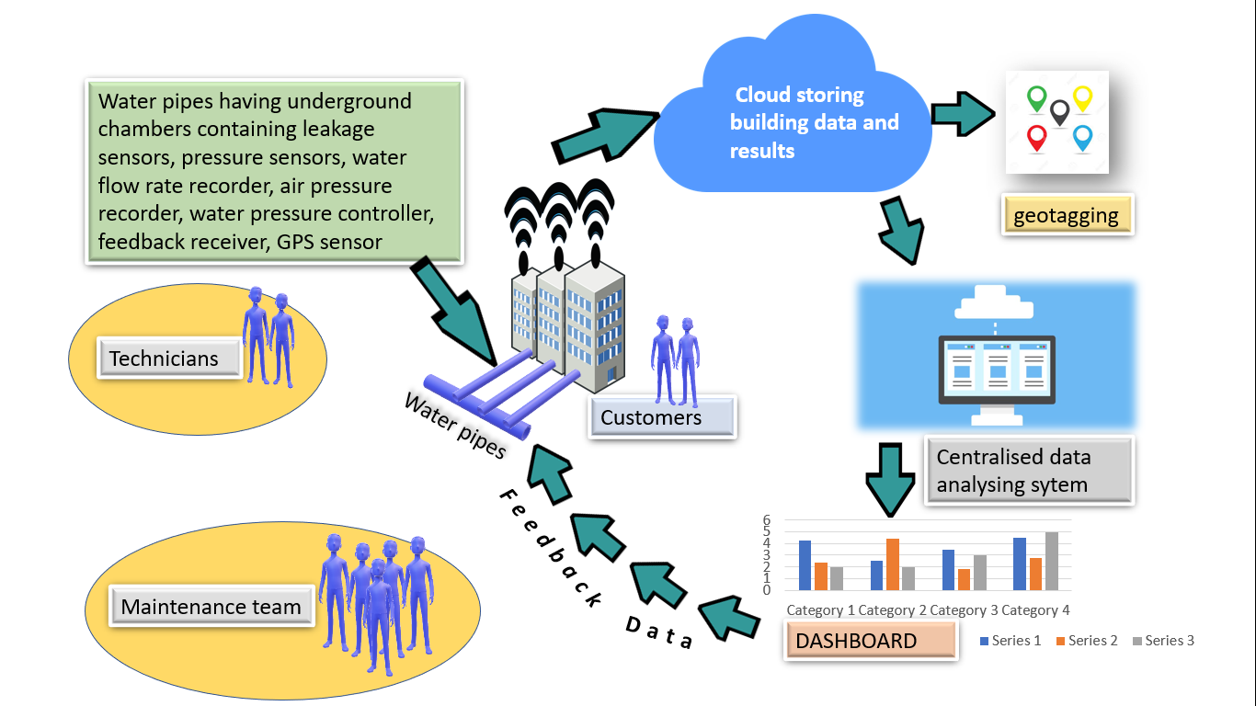

Above architecture describes the system. The underground chamber established near every building account for the following components:
- Arduino based IoT system
- Pressure sensor
- Leakage sensor
- GPS sensor
- Data recorder and transmitter
- Display screen
This chamber near the pumping stations makes the Data recorded Accessible by pushing the data to a cloud system. There are multiple chambers in our digital system, Data from each chamber is handled by the cloud as separate channels, Cloud also identifies and channelizes any SoS calls by the consumers, Validate the data for different localities.
Data for all buildings are available in a single platform (here in our case its “THINGSPEAK”). Now the data is sent to a centralized system for deep mining and data analysis. Now using supervised learning, the above data forms dashboard and graphs. TensorFlow works on this graph, scans it by vector regression methodology ensuring an efficient use of data. This gives a classified information of the locality facing a problem (if any). Now checking the pressure sensor’s graph and leakage sensor’s graph, the building with the problem and problem itself Is sorted and through GPS sensors the exact location of the building is tracked for the maintenance team to work upon. In real world problem it is not likely to get an exactly separate line dividing the data within the space. And we might have a curved decision boundary. We might have a hyperplane which might exactly separate the data but this may not be desirable if the data has noise in it. It is better for the smooth boundary to ignore few data points than be curved or go in loops, around the outliers
Other activities that will be a part of INWADIS would be:
- Underground transfer of water from areas having abundant water to areas facing acute water shortage by analyzing the pressure sensor graphs for every locality.
- This system can be applied in irrigation field where in place of pressure sensors and leakage sensor the use of humidity and temperature sensors can be made and water supply can be processed accordingly.
- Flood conditions can be prevented by diverting the extra amount of water from dams directly to areas facing scarcity of water.

4. Productization

Regularity Standards

INWADIS ensures its efficiency and sustainability by:

More efficient handling of operations:
By providing some real-time operations, organizations can make use of real-time data and make smarter decisions. The real-time data obtained will help authorities and concerned individuals make smart and concrete decisions. Also, these real-time data obtained from sensors and less human intervention help smart systems to improve your water management practices.

More concrete efficiency and productivity:
IoT helps users determine the real-time data and provides information to make smarter and more intelligent decisions for your home and business. Also, these predictive maintenance features help to provide predictions about failures that might occur in the future. You can further use these patterns to fix risks in an instant. Finally, the output is more productivity and more efficiency of the system.

Testing
CLT (central location test) will be used for testing INWADIS.
In an AR supported environment along with proper functioning of IoT base devices, the consumes can participate in the research. The target audience are real estate owners and people with their own houses excluding flats.
CLT ensures the tests are getting conducted within the observation of a moderator enabling the INWADIS to direct the research according to consumer behavior and feedback. Since this is a new system, so before the mass production it is essential to test it.
Observing the satisfaction among the consumers by analyzing how efficiently their problems are being solved shows the first impression of INWADIS.

Modularity
Since INWADIS incorporated equipment and software tools from various dimensions of technology, it has successfully ensured the product modularity of proposed solution.
The product equipment can be assembled from different firms and connected to a centralized clouds and data processing system as well as there will be firms providing the complete product itself right from the installation to cloud connection.

(
Scalability

As we know that the water for the domestic use and drinking purposes are decreasing day by day and although the water is available but it is not being used efficiently due to non-uniform water distribution, wastage of water , leakage in the pipes etc.. Seeing a very urgency in this growing need INWADIS brings a solution in a broad dimension.
The inclusion of smart irrigation channels, smart transfer of water from surplus areas to areas facing water scarcity, prevention of flood conditions in areas around India and the world, INWADIS ensures a great deal in terms of product scalability.

Quality and Reliability

The INWADIS is so efficient system because of the different sensors and technology used in the proposed system. IoT sensors also provide data that helps in the real-time tracking of all the assets performing their tasks of tracking assets. They provide more visibility into the processes using different mechanisms. This includes monitoring of different pumping stations, the pressure of the water, leakage problem in the system and many other things related to water and water resources. Not only this, the real-time data tells you a lot more. For instance, emergency and other related activities that occur in the end-to-end processes. Analytics about the Internet of Things helps us to manage different irregularities as well. Also, it provides users with a real picture so that we can make more intelligent decisions for our proposed solution.
Internet of Things and related systems bring about different advantages to the elements present in the industry. In short, it provides a new way that can help in collecting data, keep a check and problem-solving. It is one of the most exciting time for Internet of Things to get into action. It has created new ways for other elements to stay active in different industries.

5. Tools and Environment

Since the productization is to be tested we expect the following tools to be used for developing the system.

5.1 Simulation & Testing

TensorFlow is used for simulating the management system. TensorFlow is used for detection of images plotted in graph.

MATLAB Will be used for simulating the system. During the learning process the data set would be taken from the reference set. But have to generate a set of data with random data in the given ranges of values. For these purposes we would be using the MATLAB system.

While testing various different corner cases has to be developed including
Sensors malfunctioning, data manipulation in cloud and some other cases like leakages of pipes in some areas.

5.2 Cloud

Cloud4rpi will be used as IoT platform because of its flexibility and its cheeky nature to be used https://cloud4rpi.io/ It also has a good range of support for tools and devices.

5.3 Interface

Keras would be used to run the codes of tensorflow.AR would be used in the for-Technician training.
5.4 Physical :

Arduino
Data recorder and Transmitter
Display
GPS sensor
Pressure Sensors
Leakage Sensors

6. References :

1.https://www.biz4intellia.com/blog/iot-smart-water-a-big-technological-splash/
2.https://www.ca.com/en/blog-highlight/the-future-is-modular-iot-microservices-and-music-gear.html
3.https://www.smart-energy.com/industry-sectors/business-finance-regulation/using-internet-of-things-for-water-management/
4.https://www.youtube.com/watch?v=3-1qxKcOSeg
5.https://www.youtube.com/watch?v=a8w-o1fJK1k&feature=youtu.be

